**Web Development Assignment**

**Assignment Brief**

# Scenario

As an independent front and backend web developer currently working with Solihull City Council, you have been tasked with creating a website aimed at encouraging young people to adopt health-conscious habits and understand the importance of living a healthy lifestyle. The council recognizes the challenges faced by young individuals balancing study, work, and social commitments, often leading to stress and unhealthy lifestyles. Therefore, there is a critical need to educate this demographic on prioritizing activities such as exercise, healthy eating, and adequate sleep to foster overall wellbeing.

# Content

The website should provide comprehensive information on various aspects of health and nutrition, including but not limited to:

Healthy eating habits and nutrition guidelines.

Importance of regular exercise and recommended fitness routines.

Strategies for improving sleep quality and establishing healthy sleep habits. Additional topics relevant to promoting overall well-being.

**Sitemap**

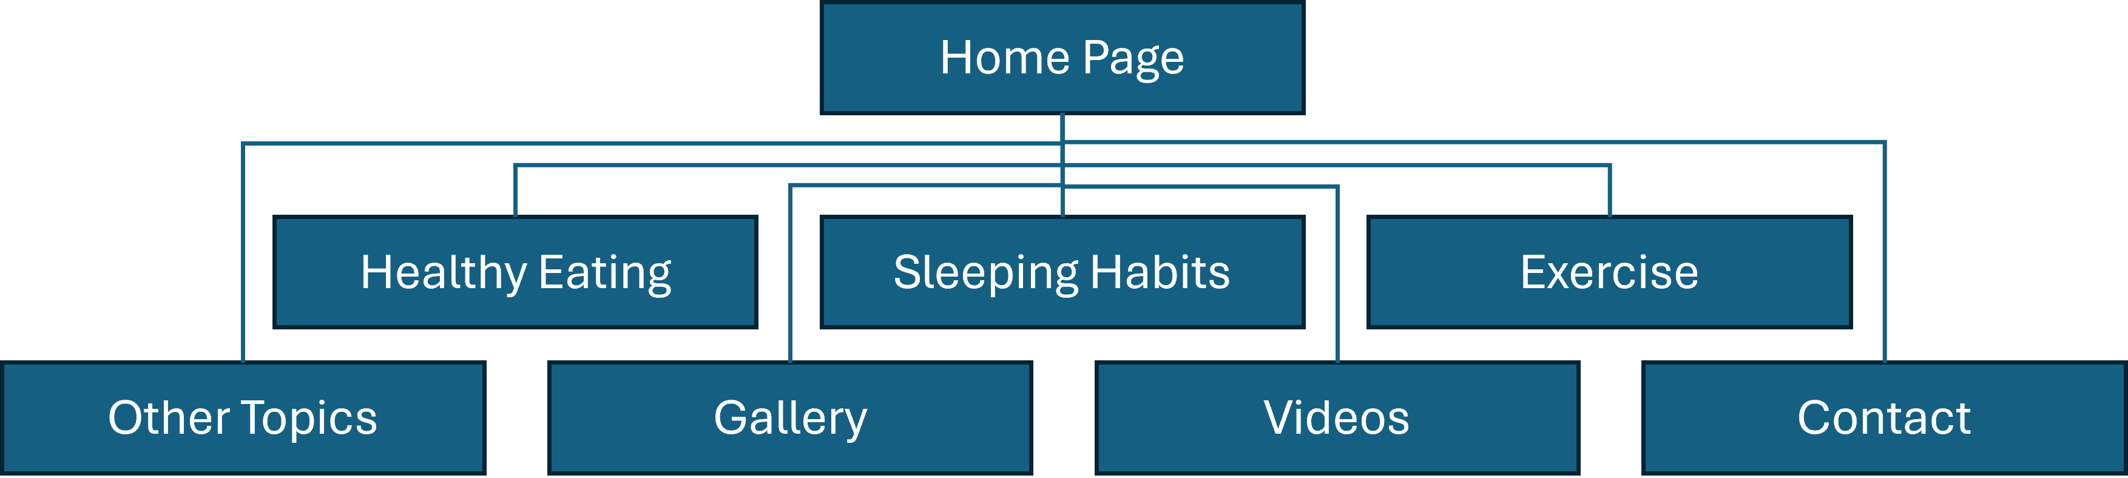

**Wireframe Models**

# Required Pages

Home - Introduction and overview of covered topics.

Healthy Eating - Information and tips on maintaining a balanced diet.

Sleeping Habits - Guidance on achieving quality sleep.

Exercise - Benefits of regular physical activity and exercise routines.

Other Topics – Links providing further information on topics.

Balancing study, work, and social commitments

Stress and unhealthy lifestyles

Overall well-being

Images - JavaScript-powered image gallery with text descriptions.

Videos - video gallery.

Contact - Form for visitor inquiries and feedback

**

**Page Designs**

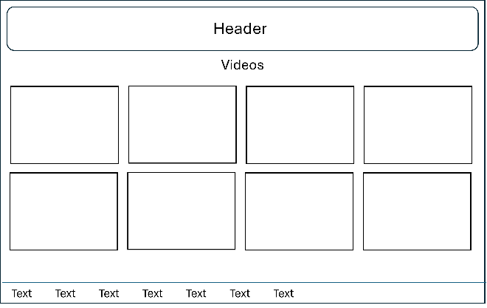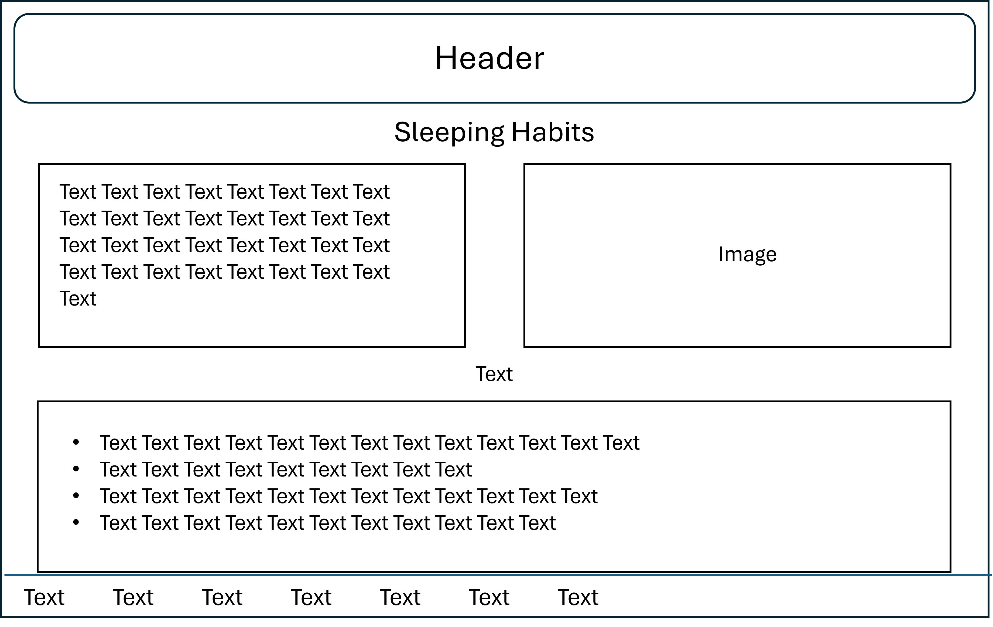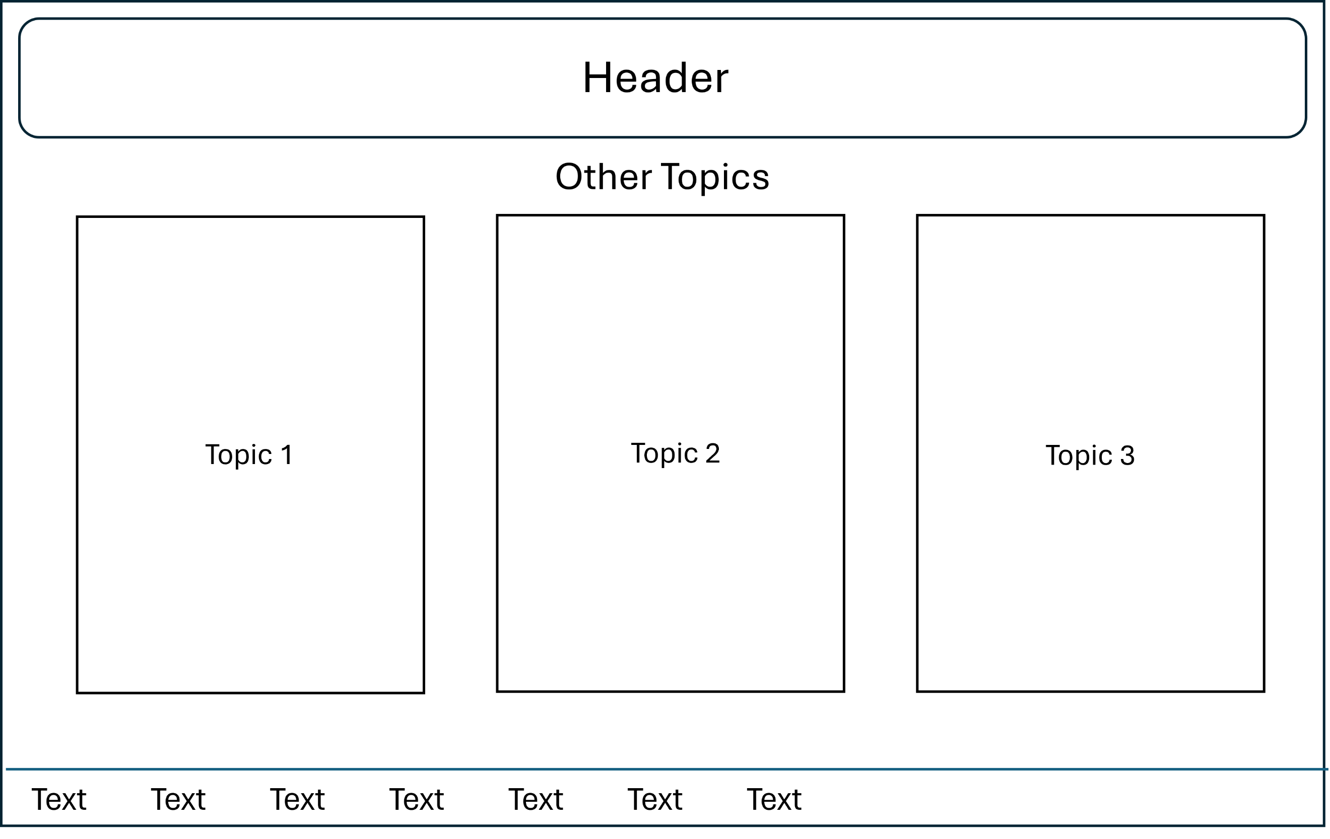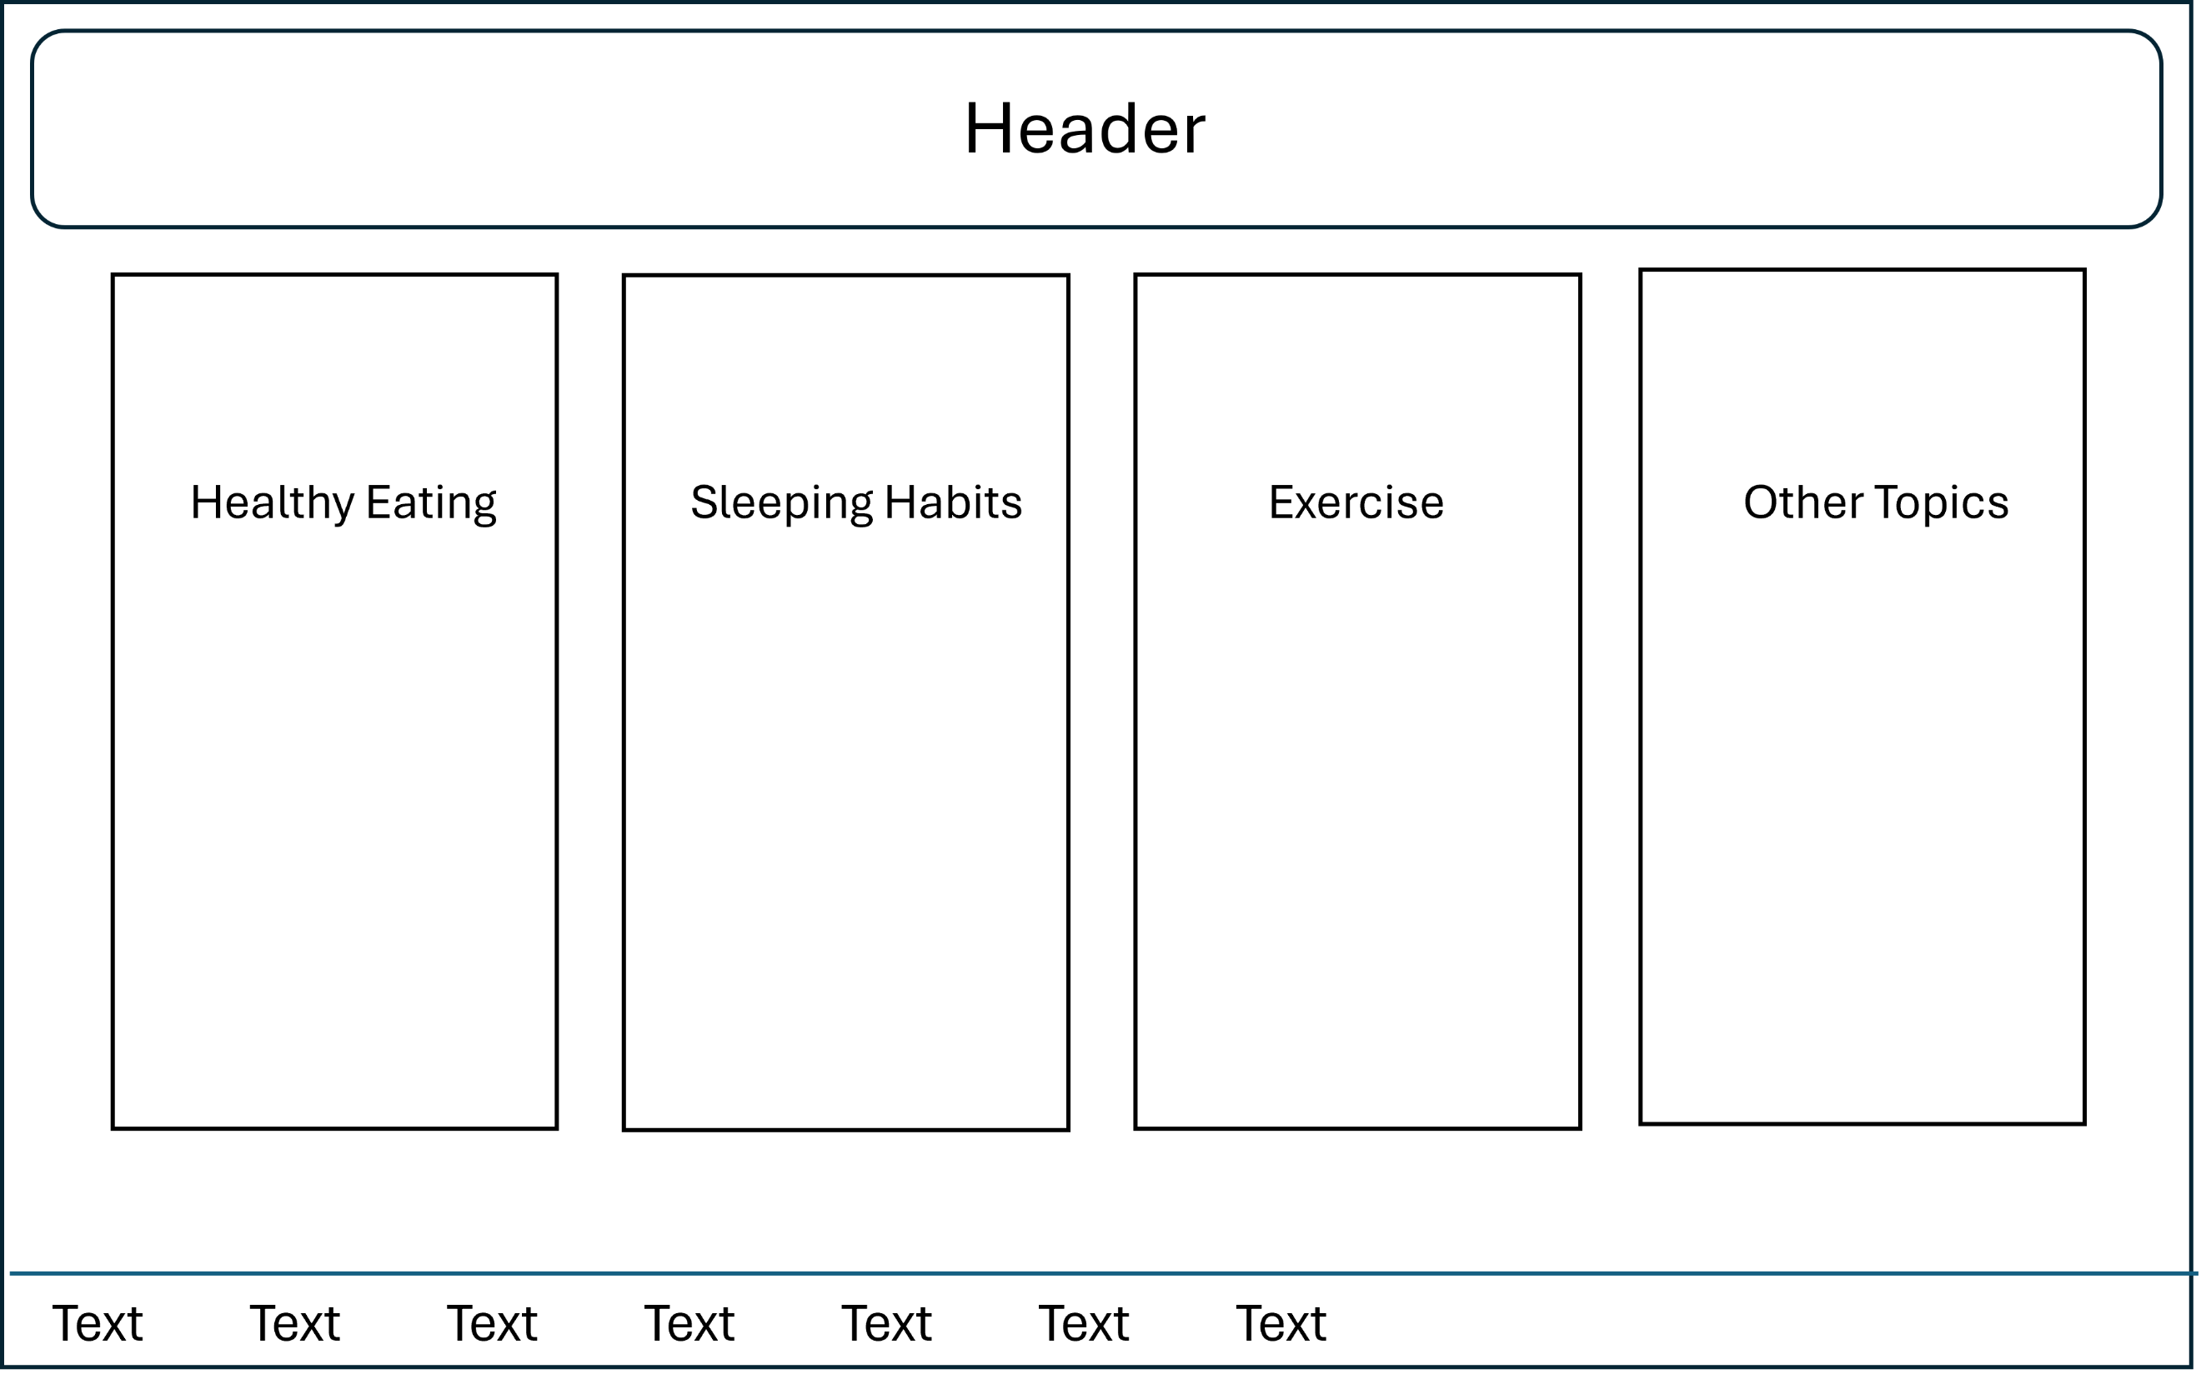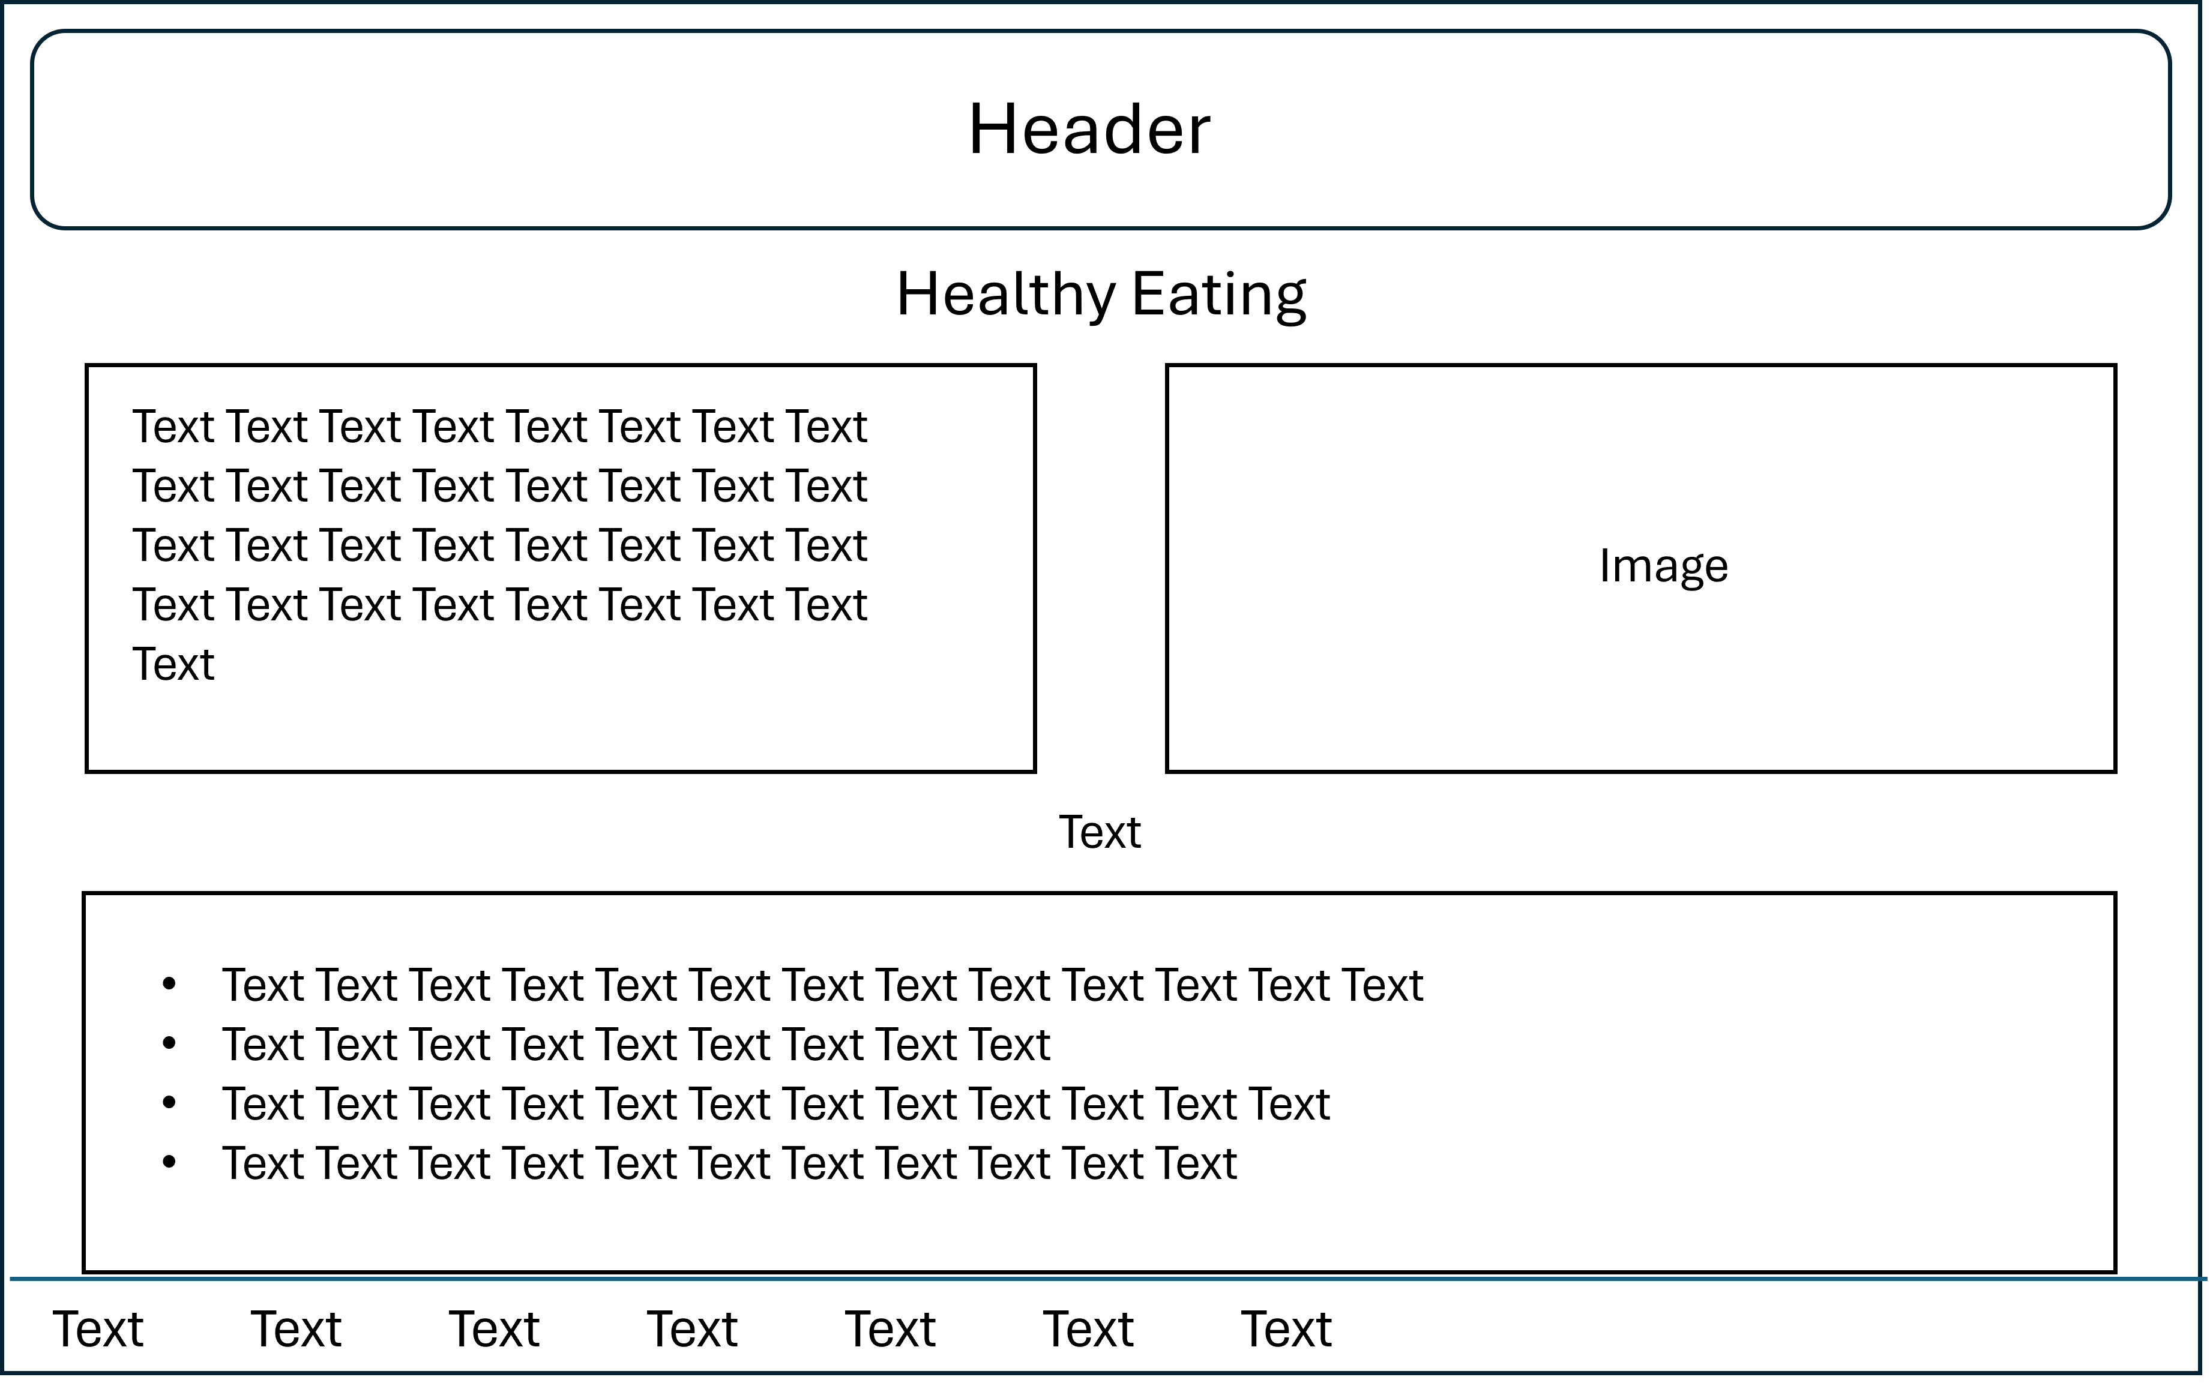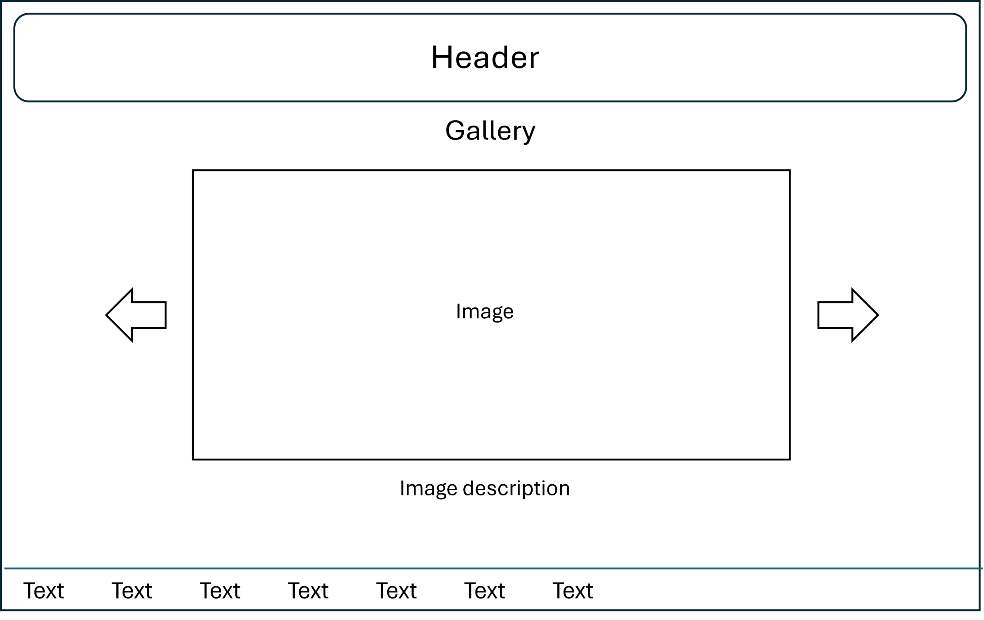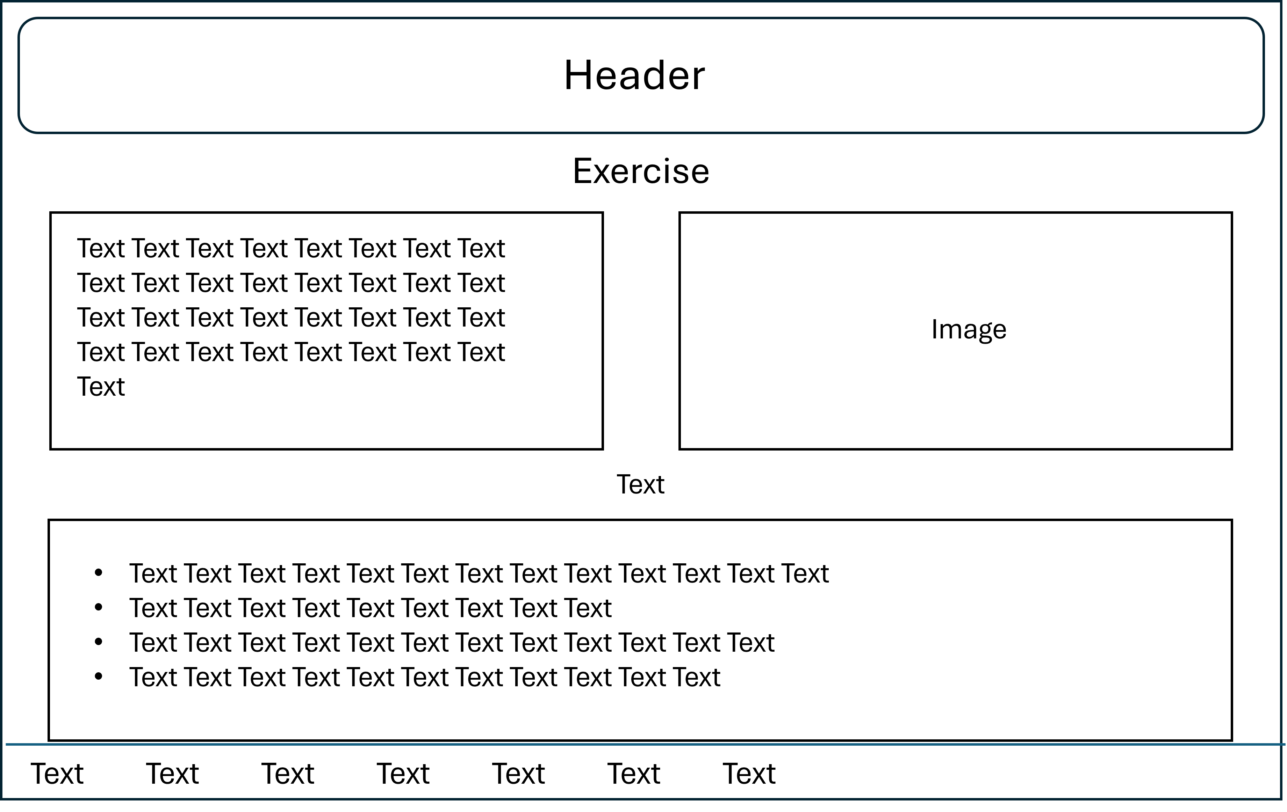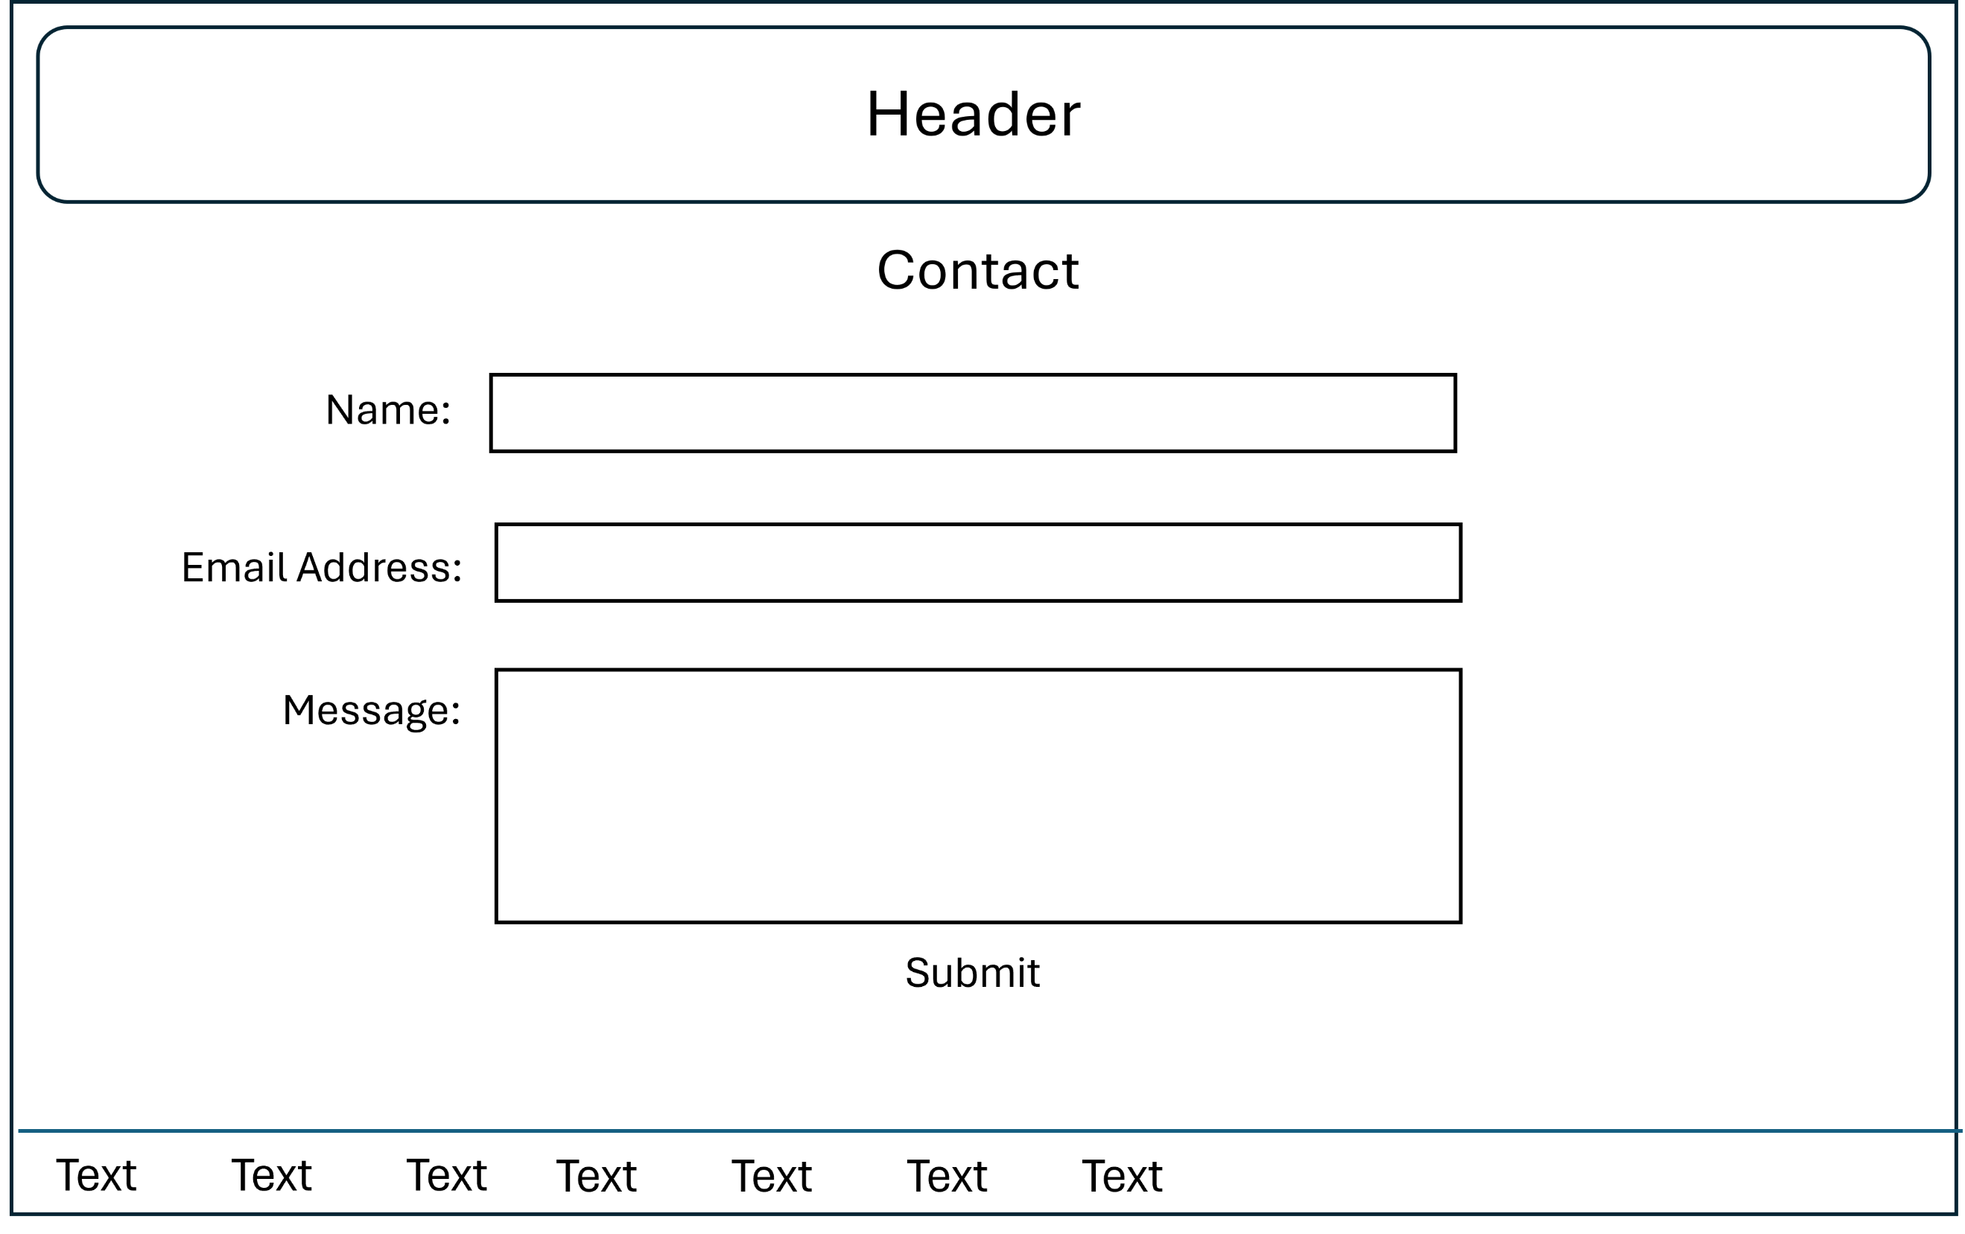

**Research**

# Healthy Eating

The key to a healthy diet is to eat the right amount of calories for how active you are so you balance the energy you consume with the energy you use. If you eat or drink more than your body needs, you'll gain weight; if you eat and drink too little, you'll lose weight.

You should eat a wide range of foods to make sure you're getting a balanced diet and your body is receiving all the nutrients it needs.

**Tips**

**-** Base your meals on higher fibre starchy carbohydrates

- Eat lots of fruit and veg

- Eat more fish, including a portion of oily fish

- Cut down on saturated fat and sugar

- Eat less salt

- Get active and be a healthy weight

- Do not get thirsty

- Do not skip breakfast

# Sleeping Habits

Your behaviours during the day, and especially before bedtime, can have a major impact on your sleep. They can promote healthy sleep or contribute to sleeplessness.

Your daily routines - what you eat and drink, the medications you take, how you schedule your days and how you choose to spend your evenings - can significantly impact your quality of sleep.

**Tips**

- Keep a consistant sleep schedule. Get up at the same time every day, even on weekends or during holidays.

- Set a bedtime that is early enough for you to get at least 7-8 hours of sleep.

- Don't go to bed unless you are sleepy.

- If you don't fall asleep after 20 minutes, get out of bed. Go do a quiet activity without a lot of light exposure. It is especially important to not get on electronics.

- Establish a relaxing bedtime routine.

- Make your bedroom quiet and relaxing. Keep the room at a comfortable temperature.

- Limit exposure to bright light in the evenings.

- Turn off electronic devices at least 30 minutes before bedtime.

- Don't eat a large meal before bedtime. If you are hungry at night, eat a light, healthy snack.

- Exercise regularly and maintain a healthy diet.

- Avoid consuming caffeine or alcohol in the afternoon or evening.

# Exercise

Regular exercise has been shown to help boost energy levels and enhance your mood, and is paramount to maintaining a healthy body. Moreover, the benefits of regular physical activity include reducing the risk of many chronic diseases.

**Tips**

- Exercise can make you feel happier

- Exercise can help with weight management

- Exercise is good for your muscles and bones

- Exercise can increase your energy levels

- Exercise can reduce your risk of chronic disease

- Exercise can help skin health

- Exercise can help your brain health and memory

- Exercise can help with relaxation and sleep quality

- Exercise can reduce pain

# Other Topics

Topic 1 - Mental Health

https://www.google.com/url?sa=t&rct=j&q=&esrc=s&source=web&cd=&cad=rja&uact=8&ved=2ahUKEwjTwMD7pICGAxUISkEAHf7MDj0QFnoECAwQAQ&url=https%3A%2F%2Fwww.nhs.uk%2Fmental-health%2F&usg=AOvVaw3YWzT5UqMyX-63mnrR-VMg&opi=89978449

Topic 2 - Negative Lifestyle Choices https://www.google.com/url?sa=t&rct=j&q=&esrc=s&source=web&cd=&cad=rja&uact=8&ved=2ahUKEwjUwa71rIqGAxW0VfEDHeAnAuIQFnoECBEQAQ&url=https%3A%2F%2Fwww.bbc.co.uk%2Fbitesize%2Fguides%2Fz3shycw%2Frevision%2F3&usg=AOvVaw0q0n_BCxi12rRR-vFD6mSq&opi=89978449

Topic 3 - Study, Work, and Social Life Balance <https://www.google.com/url?sa=t&rct=j&q=&esrc=s&source=web&cd=&cad=rja&uact=8&ved=2ahUKEwjr_KmkroqGAxXYVPEDHWZVCx4QFnoECBIQAQ&url=https%3A%2F%2Fwww.studentjob.co.uk%2Fblog%2F1100-balancing-act-study-work-and-social-life-balance-a-student-s-guide&usg=AOvVaw3hRU3MiObo-UhlLgcxnf_O&opi=89978449>

# Videos

Healthy-Eating

Video 1

https://youtu.be/XMcab1MFaLc?si=CeBWvMvf5IuX3P2c

Video 2

https://youtu.be/mMHVEFWNLMc?si=sCaCs3O_4XMp2seP

Video 3

https://youtu.be/jwWpTAXu-Sg?si=riSDHIgImdGepDkE

Sleeping-Habits

Video 1

https://youtu.be/FWIb0iUmGNY?si=YZmkKVs03f9a0ScW

Video 2

https://youtu.be/A4Zs0NNF9Dc?si=HWKRf25aammL7X37

Video 3

https://youtu.be/t0kACis_dJE?si=FWDYtL9ItTV0dWr9

Exercise

Video 1

<https://youtu.be/VWj8ZxCxrYk?si=Wzy8UTKIeopo09V4>

Video 2

<https://youtu.be/s6U3vDtdzrE?si=gAuemoHPCeq22Cf->

Video 3

https://youtu.be/zGf-9VVgCDw?si=F5tqu5wx45MKCOt1